<A BIDV based smart banking>

Use-Case-Realization Specification: <Transfer>

Version <1.0>

Revision History

|  |  |  |  |
| --- | --- | --- | --- |
| **Date** | **Version** | **Description** | **Author** |
| <20/12/2022 > | <1.0> | <Analyze and write use case> | <Đàm Thị Linh> |
|  |  |  |  |
|  |  |  |  |
|  |  |  |  |

Table of Contents

1. Introduction 2

1.1 Purpose 2

1.2 Scope 2

1.3 Definitions, Acronyms, and Abbreviations 2

1.4 References 2

1.5 Overview 2

2. Flow of Events—Design 2

3. Derived Requirements 2

Use-Case-Realization Specification: <Transfer>

# Introduction

## Purpose

This document describes how the use case for transferring money using a smart banking app is realized in a design model, which is specially illustrated by sequence diagram and class diagram.

## Scope

This document applies to transfer money on a mobile smart banking app.

## Definitions, Acronyms, and Abbreviations

User: who uses the service of the smart banking app

MainUI: the GUI displayed as home page

SelectBeneficiaryUI: GUI displayed for choosing target account

TransactionInformationUI: GUI displayed for entering money and transaction remark (message)

ConfirmTransactionUI: GUI displayed for check PIN and end the transaction

CheckAccountController: controller to get target account full name

CheckCardController: controller to get card information

CheckPINController: controller to check PIN

BeneficiaryController: controller to work with saved beneficiary

Beneficiary: target account

SystemAccount: all account of the system

UserAccount: the account of user

## References

None

## Overview

The Use-Case Realization Specification for transferring money is offered in detail to aid in understanding and implementation. It will be summarized into a textual description in this document. There are sequence and class diagrams that show how the use case is implemented. The final section, "Derived Requirements," specifies all requirements, including non-functional requirements, on use-case realizations that were not taken into account in the design model but that must be addressed during implementation in text.

# Flow of Events—Design

## sequence diagram

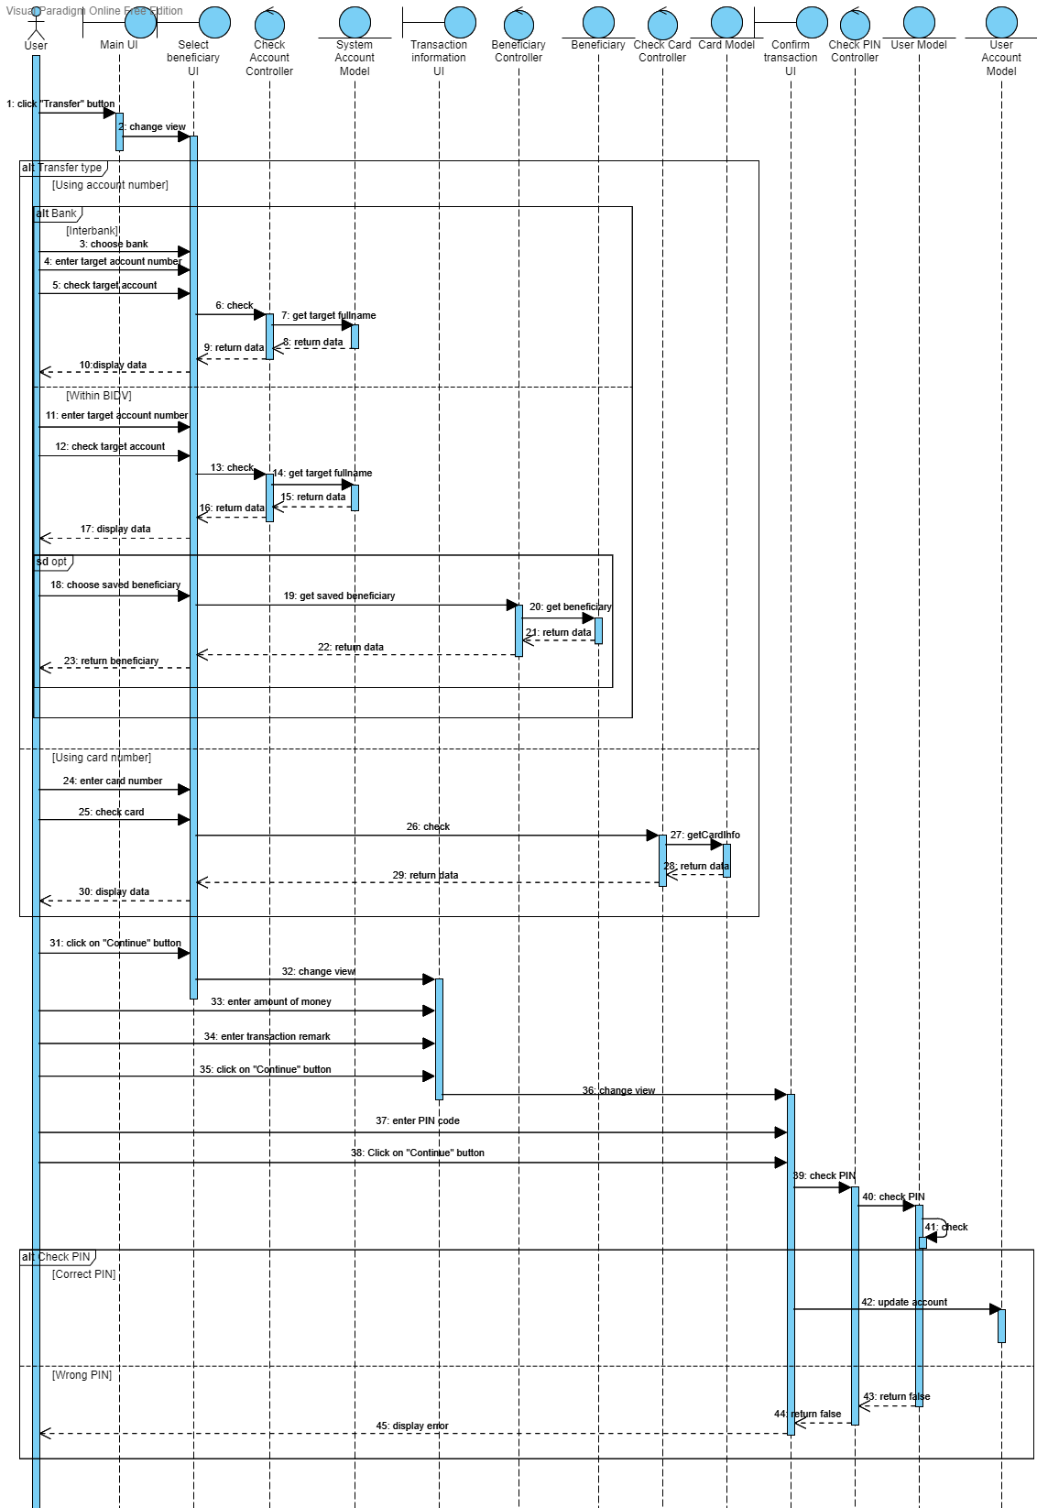

## class diagram

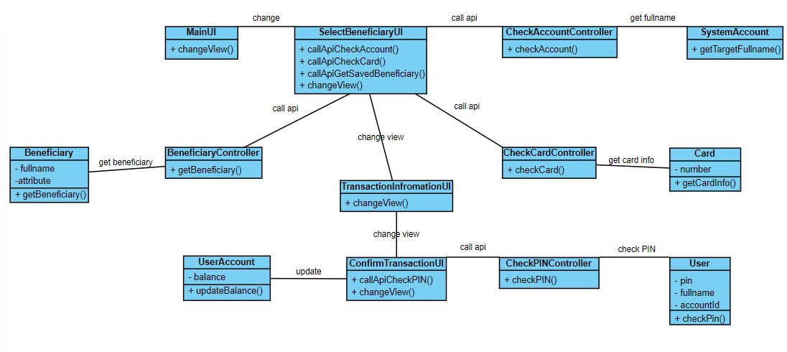

# Derived Requirements

# 3.1 < Speed >

The execution speed should be as fast as possible. It means that when the user wants to take another transfer right away, make sure the account balance is updated.

**3.2 <The amount of money transferred is greater than 1000 VND>**